Q1-

Q2-

Q3-

Q4-

Q5-

Q6-

Q7-

Q8-

Q9-

Q10-

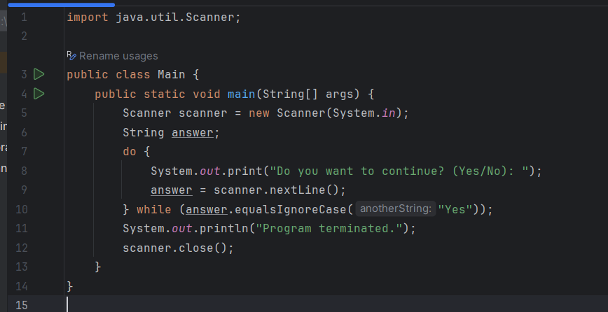

Q11-

